
Jolly Helmet
Make your Helmet Happy Again!
Clean it. Dry it.
Wear it happy.
Coin-operated helmet cleaning and drying stations
MEJES, JERAHMEEL ALZEL M.
CRUZ, DEAN RYAN P.
MENDOZA, RICAH S.
MARTOS, KRISTINA E.
DEVELOPERS AND DESIGNERS
USER MANUAL - CUSTOMER GUIDE

Jolly Helmet User Manual
Customer guide
Revision 11, 4 November 2026. Made by MEJEZ STUDIO.
This book is one of three: Customer guide, Admin guide, Technician guide (with the Reference). The full manual, with everything in one file, is JollyHelmet_UserManual_v11.pdf.
Two PDFs come with this book. The plain file (single pages in reading order): print double-sided, flip on the LONG edge, Letter size (A4 at 'fit'). The file whose name ends in _BOOKLET (two pages on each landscape sheet, the last page next to the first): print double-sided, flip on the SHORT edge, 100 percent (actual size), then fold the whole stack in half and staple on the fold. Every chapter starts on a right-hand page; the page count is a multiple of 4 so the booklet folds cleanly.
Questions or faults: MEJEZ STUDIO, 0975 791 5832.

Contents
Customer guide 5
Meet the machines 5
Before you start 6
Using a station: cleaning and drying 7
Prices and time 9
Special screens and safety 10

Customer guide

Welcome to Jolly Helmet!
A self-service station that cleans and dries your motorcycle helmet while you wait.

Meet the machines
There are three Jolly Helmet stations: Box 1, Box 2 and Box 3. They all work the same way. Each one has a touch screen, a coin slot and a door, and each one can clean and dry your helmet.

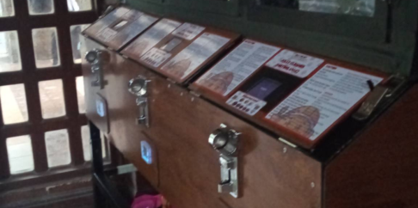 | 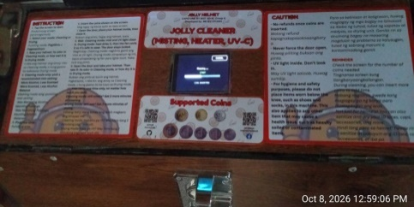 | 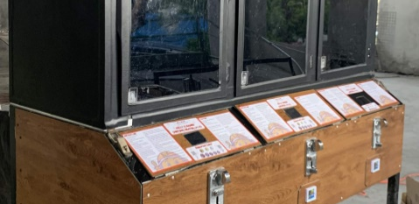

Mode | What it does
CLEANING | Removes odor: UV light plus a fine mist of the cleaning liquid, then 3 minutes of automatic drying (AUTO DRY). Offered only when the cleaning liquid is high enough; otherwise only DRYING.
DRYING | Dries a wet helmet with warm air and UV light, then lets it cool down (COOL DOWN) before you take it out.

Tip / Paalala: Sa kahit anong Box, piliin ang CLEANING kung may amoy ang helmet at ang DRYING kung basa ito. Pagkatapos ng CLEANING, awtomatiko nang natutuyo ang helmet mo.

Which machine is free?
Look for the QR sticker on the machines. Scan it with your phone camera. A page opens that shows Box 1, Box 2 and Box 3 as FREE, IN USE (with about how many minutes are left) or OUT OF ORDER. You do not need an app or a password. The button at the top changes the language between English and Filipino. When a machine is running your cycle you may also tap Add your name on its card and type a nickname (12 letters at most). Everybody who opens the page sees it, so use a nickname, not your full name. It disappears by itself when your cycle ends.
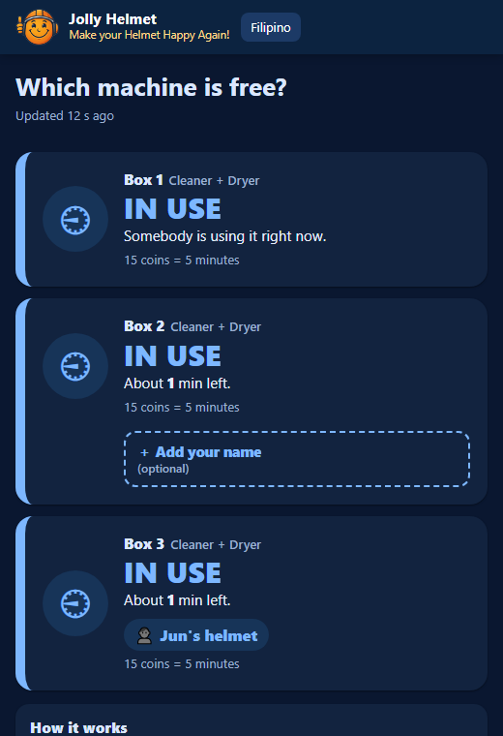
The customer status page: which machine is free (phone)

Tip / Paalala: I-scan ang QR sticker para makita kung aling makina ang libre. Pindutin ang "Filipino" sa itaas ng page.

Before you start
You need: your helmet and coins. The machine counts coins by value: a one-peso coin counts as 1.

How the touch screen works
- Big words (yellow) tell you what to do next: OPEN, PLACE, CLOSE, TAKE.
- Buttons are the dark boxes with white words. Tap them once.
- The screen blinks briefly now and then. This is normal, it refreshes itself.

Never put your hand in while the machine runs. If you open the door, the machine pauses by itself.

Using a station: cleaning and drying
Box 1, Box 2 and Box 3 work the same way, and every one does both jobs. A station cleans (UV light and a fine mist), then dries the helmet, or it only dries. You pay the coins and the machine runs for the time they buy.

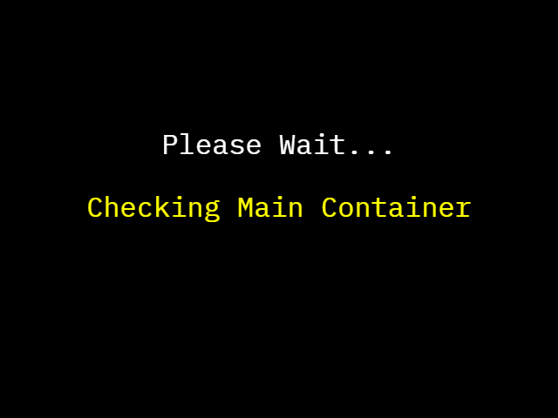  1. CHECKING (2 seconds) | 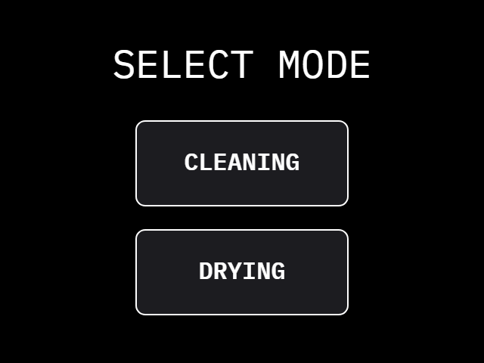  2. SELECT MODE | 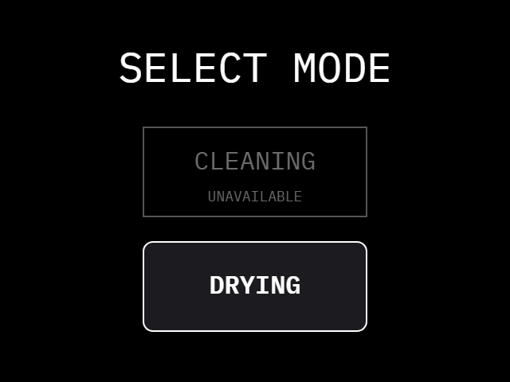  2b. CLEANING greyed out: dry only
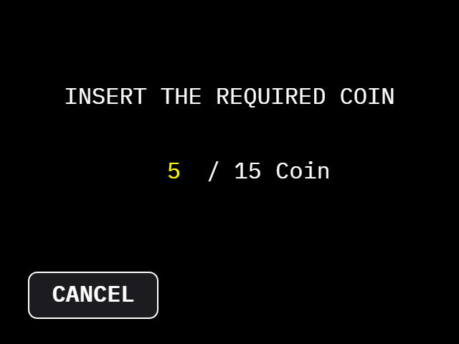  3. INSERT THE REQUIRED COIN | 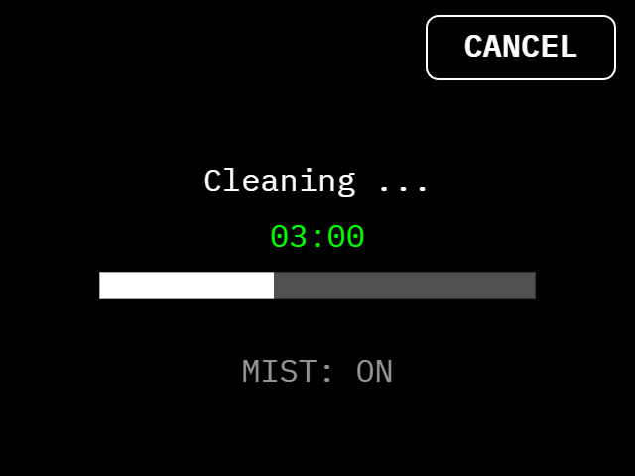  4. CLEANING (CANCEL top right) | 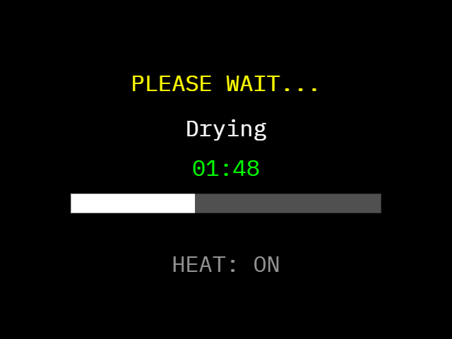  5. AUTO DRY after a cleaning
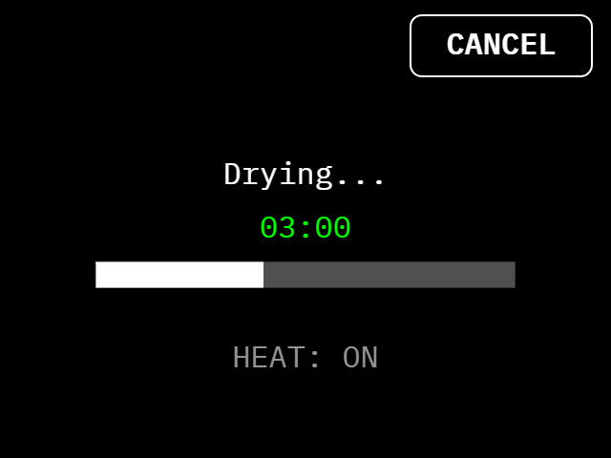  DRYING mode: warm air and UV | 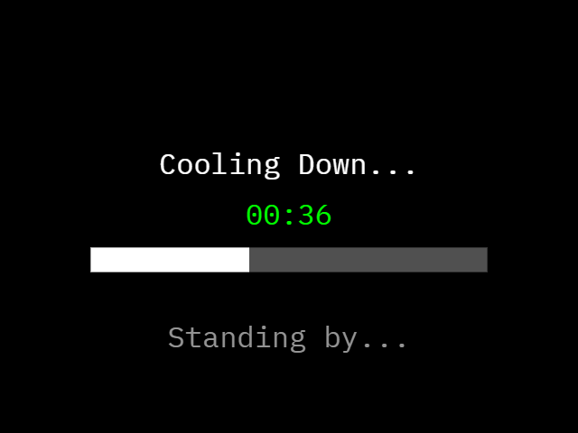  COOL DOWN after drying | 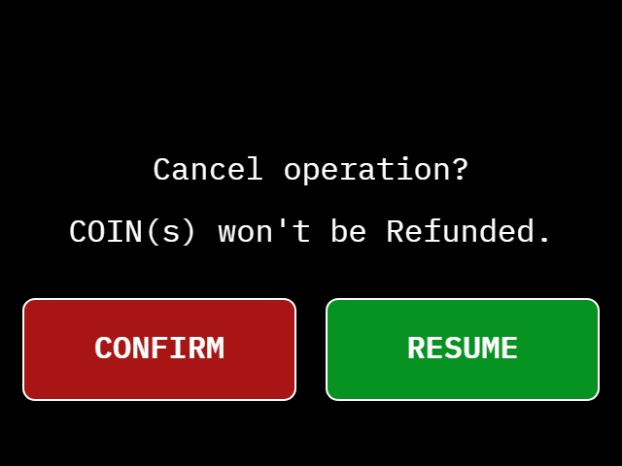  CANCEL: CONFIRM or RESUME

- Tap the screen. For 2 seconds it says Checking Main Container: the machine asks the Refilling Station whether the cleaning liquid is high enough. Tap again at WELCOME.
- SELECT MODE: tap CLEANING or DRYING. If CLEANING is grey (SELECT DRY ONLY), the liquid is low or the Refilling Station is not answering: only DRYING can be chosen.
- INSERT THE REQUIRED COIN: insert coins until the count reaches the number asked (15 coins = 5 minutes). CANCEL takes you back to the start. After the last coin the station waits about 2 seconds so a big coin is counted in full: every coin counts, so with a 20-peso coin for 15 asked, the extra 5 coins add 100 seconds.
- OPEN, PLACE, CLOSE: the door unlocks and the buzzer beeps. Open it, put your helmet in, close the door.
- The machine runs for the time your coins bought. CLEANING uses UV light and mist, then AUTO DRY dries the helmet for 3 minutes with UV light and warm air (the warm air stops for the last 30 seconds). DRYING uses warm air and UV light, then COOL DOWN lets the helmet rest for 60 seconds.
- OPEN, TAKE, CLOSE: the door unlocks again. Take your helmet out and close the door. The screen says "Thank you for your patronage!".

Adding coins and cancelling
- You can add coins while a cleaning or a drying is running. Every coin adds time, up to 90 coins (30 minutes) in all. Coins are not taken during AUTO DRY and COOL DOWN.
- CANCEL (top right) asks "Cancel operation? COIN(s) won't be Refunded." CONFIRM stops the run, RESUME carries on. A cancelled cleaning still goes through the 3-minute AUTO DRY, because the helmet is wet. A cancelled drying goes through the 60-second COOL DOWN. Then the door unlocks.
- If you open the door while the machine runs, it pauses (SAFETY PAUSE) and switches the UV light and the heat off. Close the door and it carries on.

If the power goes out or a station shows OUT OF ORDER
A station never keeps a helmet locked in on purpose. If it cannot work, the screen shows OUT OF ORDER. When your helmet is inside and the door is shut, the screen also says "Your helmet is still inside. Take it out, then close the door.", the door unlocks by itself and the buzzer beeps (100 ms on, 500 ms off) until you open the door. During a power cut a backup battery (UPS) keeps the screen, the sensors and the door lock alive, so the same thing happens. If the door stays locked, do not force it: tell the staff. A session that was paid but cut by a power failure is not restored.

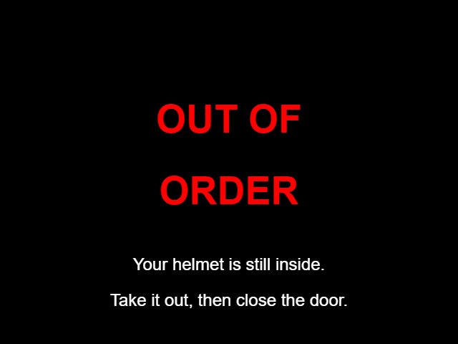
OUT OF ORDER, helmet still inside

Tip / Paalala: Kung kulay abo ang CLEANING, DRYING lang ang magagamit. Subukan muli ang CLEANING mamaya. Kung may nakalagay na OUT OF ORDER at nasa loob ang helmet mo, bubukas ang pinto nang kusa at tutunog ang buzzer: kunin ang helmet at isara ang pinto.

Prices and time

Every station (Box 1, Box 2 and Box 3): 15 coins = 5 minutes, and nothing else to choose. INSERT THE REQUIRED COIN asks for the first 15 coins; every extra coin adds 20 seconds, up to 90 coins (30 minutes) in all. The 3-minute auto-dry that ends every cleaning is free.

These are the starting prices. The admin can change them, so always check the INSERT THE REQUIRED COIN screen for the exact amount.

Special screens and safety

Special screens
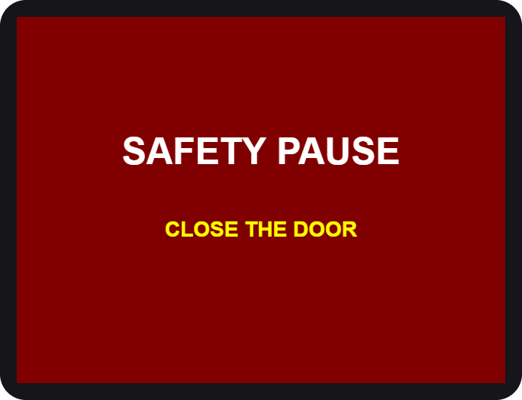  Door opened during a run |   Station needs service

You see | What it means / what to do
SAFETY PAUSE | The door was opened. Close it and the run continues.
HELMET NO DETECTED | No helmet seen. Open the door and place it again.
OUT OF ORDER | The station cannot work now. If your helmet is inside, the door unlocks by itself and the buzzer beeps: take the helmet out and close the door. Then use another station and tell the staff.
CLEANING greyed out (SELECT DRY ONLY) | The cleaning liquid is low, or the Refilling Station is not answering. DRYING still works. Try CLEANING again later.
MAINTENANCE | A technician is working on the station.
Checking Main Container | Two seconds after your first tap the machine checks the liquid. Wait.
AUTO DRY (Drying...) | The cleaning is over. UV light and warm air dry the helmet for 3 minutes. Wait.
COOL DOWN | After DRYING nothing runs for a minute so the helmet can cool. Wait.
Your helmet is still inside | The machine is out of order. The door is unlocked and the buzzer beeps: take the helmet out and close the door.

Safety first
- Helmets only. Do not put bags, gloves, liquids or anything else inside.
- Keep your hands out while the machine runs. Hot air and UV light are used.
- UV light is strong. Never look into the chamber while it is on. The door must be closed.
- Do not force the door. It is locked on purpose while the machine runs. To stop, use CANCEL on the screen. If the screen does not answer, tell the staff (see "If the door will not open").
- Remove your helmet's accessories (camera, speaker, visor tint film) if they are not heat-safe.
- Children should use the machine with an adult.
- In an emergency, tap CANCEL, then CONFIRM. The machine stops. After the short auto-dry (cleaning) or cool-down (drying) the door unlocks. If you see smoke, smell burning or see sparks, step away and call the staff at once.

If your helmet is stuck after a power cut or a fault, do not pull on the door. The door unlocks by itself and the buzzer beeps while the screen says OUT OF ORDER. Then tell the staff.

If the door will not open
The door is locked on purpose while a machine runs. Do not force it.
- A run is still going. Wait until it ends, or tap CANCEL, then CONFIRM. After the short auto-dry (cleaning) or cool-down (drying) the door unlocks.
- The screen says OUT OF ORDER and your helmet is inside. The door unlocks by itself and the buzzer beeps. Take your helmet out and close the door.
- The screen does not answer, or the door stays locked. Tell the staff. They can unlock the door from the Control Center, or as soon as the power is back.

If the machine was running, opening the door stops it (SAFETY PAUSE) and switches the UV light and the heat off. The UV light is strong: do not look into the chamber until it is off. The helmet may be warm.

Questions

Question | Answer
The screen went white. | Wait a moment, it restarts itself. If it stays white, tell the staff.
I inserted a coin but nothing changed. | Insert the coin again slowly. Tell the staff if the count does not move.
Can I get a refund? | Coins are not refunded after the run has started or been cancelled.
Which station should I use? | Smelly: choose CLEANING. Wet: choose DRYING. Every station does both.
The door will not open. | Wait until the run ends, or tap CANCEL. If the screen does not answer or the power is off, tell the staff.
Why can I only choose DRYING? | CLEANING is greyed out when the liquid is low or the Refilling Station is not answering. Dry only works. Try again later.
Can I add coins while a station runs? | Yes. Each coin adds time, up to 90 coins in all. Not during AUTO DRY and COOL DOWN.
The power went out with my helmet inside. | The station unlocks the door by itself and beeps: take the helmet out and close the door. If the door stays locked, tell the staff. A paid session that was cut by the power is not restored.
I put in a bigger coin than the machine asked for. | The station keeps counting for about 2 seconds after the last coin, then every coin counts: the extra coins add time (20 seconds each, up to 90 coins in all).

Thank you for using
Jolly Helmet
We hope to see you again!
Make your Helmet Happy Again.
MEJES, JERAHMEEL ALZEL M.
CRUZ, DEAN RYAN P.
MENDOZA, RICAH S.
MARTOS, KRISTINA E.
DEVELOPERS AND DESIGNERS
USER MANUAL - CUSTOMER GUIDE

